The study of the cross-interaction of antibodies with antigens of different types of human papillomaviruses (HPV)
Stolbikov A.S., Salyaev R.K., Rekoslavskaya N.I.
The Siberian Institute of Plant Physiology and Biochemistry of the Sibertian Branch of Russian Academy of Sciences, Irkutsk, Russia
E-mail: valkir5@yandex.ru
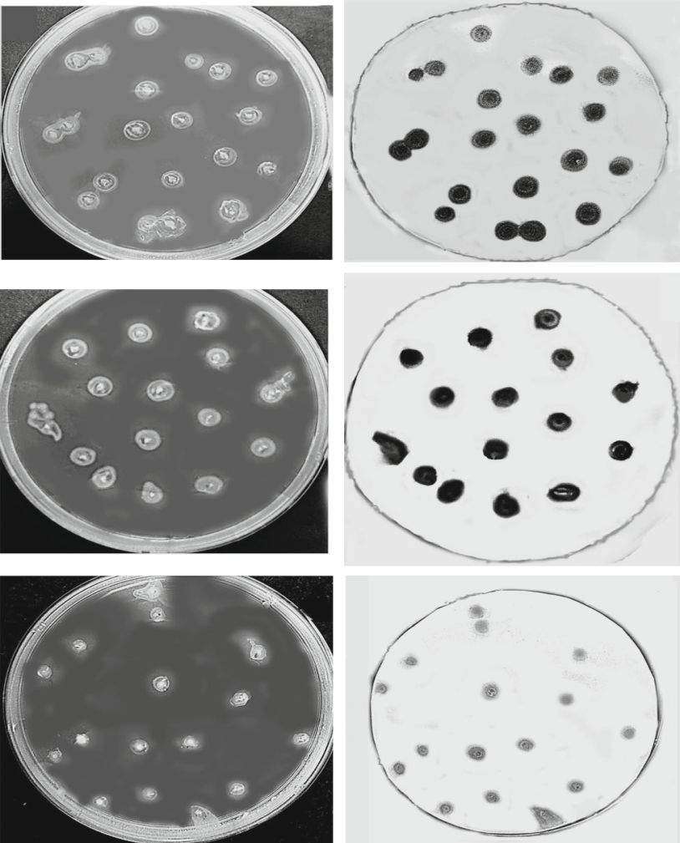
Antigenic proteins of papillomaviruses of high-risk oncogenic types HPV16 L1, HPV18 L1, HPV31 L1, HPV45 L1 as well HPV6 L1 of anogenital types were obtained in the plant expression system on the base of transgenic with these types of tomato fruits using genetic constructs: RB-> p35S->RdRP(2a+2b)->t35S->p35S->HPV16 L1 (18, 31, 45, and 6). To rise antibodies, mice were peroral vaccinated 3 times with 500 mg of vaccine material of transgenic tomato fruits with appropriate gene constructs with the interval of one month. After 8 months after last vaccination, mice peripheric blood and spleen were collected to provide analyses of the content of antibodies by ELISA and Western blot hybridization with the comparison of obtained data with results of the reaction of commercial antibodies and antigens. It was shown that all antigenic proteins HPV L1 occured to able for cross-reaction with antibodies of each type, moreover the anogenital type HPV6 L1 cross-reacted with antibodies to types HPV16 L1 (18, 31 and 45). Due to Elispot analisis, it was found that antigenic protein HPV16 L1 was able to induce syntheses of interferon, CD4+ and CD8+ T lymphocytes in blood serum and splenocytes of mice vaccinated with other types of L1 of papillomaviruses (Fig. 1, 2).
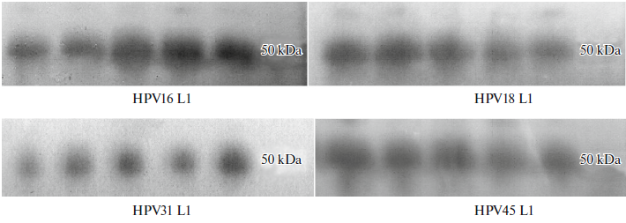
Fig. 1. Western blot hybridization of antigenic proteins HPV L1 of HPV types 16, 18, 31, and 45 isolated from transformed fruit after transformation with Agrobacterium carrying the corresponding genetic constructs. The primary antibodies were obtained from blood serum of mice vaccinated with HPV16 L1.

Fig. 2. E coli BL21 colonies with pUC57 HPV6 L1 (to the left) and after Western blot hybridization with the antibodies (to the right). The upper pair ̶ serum antibodies of mice that were orally vaccinated with the transgenic tomato fruit with HPV16 L1; the lower pair ̶ the standard antibodies to HPV16 L1.

The suggestion has been done that the cross-reaction between antibodies to some types of HPV and antigens of other types of HPV could be resulted from the similarity of antigenic determinants (epitops). To answer of this proposition, some different bioinformatic resources was attracted. It was found during this investigation that T and B lymphocytes have the common linear determinant for 4 types of papillomavirus proteins L1 16, 18, 31 and 45. Similar 3-dimensional antigenic determinants were found for B lymphocytes for HPV16 L1 and HPV18 L1. The results of the investigation of protein sequencing of 4 proteins L1 was shown that more likely antigenic determinant of T lymphocytes would be ones in the position 12-21 of the sequence. For HPV16 L1 – YLPPVPVSKV, for HPV31 L1 – YLPPVPVSKV, for HPV18 L1 YLPPPSVARV, for HPV45 L1 –YLPPPSVARV. Antigenic determinants of HPV16 L1 and HPV31 L1 were more closed to each other. The same similarity was found for HPV18 L1 and HPV45 L1 (Fig. 3).
Fig.3. Probable antigenic determinants for T cells in the protein sequences HPV16 L1, HPV 18 L1, HPV31 L1, HPV45 L1 according to the program “SYFPEITHI”

We assumed that the results of this investigation would be helpful for the creation of new perspective candidate vaccines against dangerous types of papillomaviruses.

